Experiment Number : 02 Date: 28/01/2026

Input and Output Statements in Java
Aim:
To understand and use input and output statements in Java using the Scanner class.
PRE LAB EXERCISE
QUESTIONS
What is input in a program?
Input is any data or information that a program receives to work with.
Examples: numbers typed by the user, text entered from the keyboard, data read from a file, etc.

What is output in a program?
Output is the result a program produces and gives back to the outside world.
Examples: text printed on the screen, values displayed, data written to a file, etc.

Which class is used to read input from the user in Java?
The most commonly used class to read input from the user in Java is the ‎`Scanner` class from the package ‎`java.util`.

IN LAB EXERCISE
Objective:
To read input from the user and display the output using Java input and output statements.
INPUT STATEMENT:
SCANNER CLASS
- The Scanner class in Java is used to read input from the user through the keyboard.
It is available in the package java.util.
- The Scanner object reads different types of input such as integer, float, double, and string and stores them in variables.
- To use the Scanner class, it must be imported before using it in the program.
SYNTAX:
- Scanner sc = new Scanner(System.in);
Commonly Used Scanner Methods:
- nextInt() – reads an integer value
- nextFloat() – reads a float value
- nextDouble() – reads a double value
- next() – reads a single word
- nextLine() – reads a complete line of text

PROGRAMS:
Program 1: Read and Display Name
Source Code:
import java.util.Scanner;
class ReadName {
public static void main(String[] args) {
Scanner sc = new Scanner(System.in);
System.out.print("Enter your name: ");
String name = sc.nextLine();
System.out.println("Your name is: " + name);
}
}
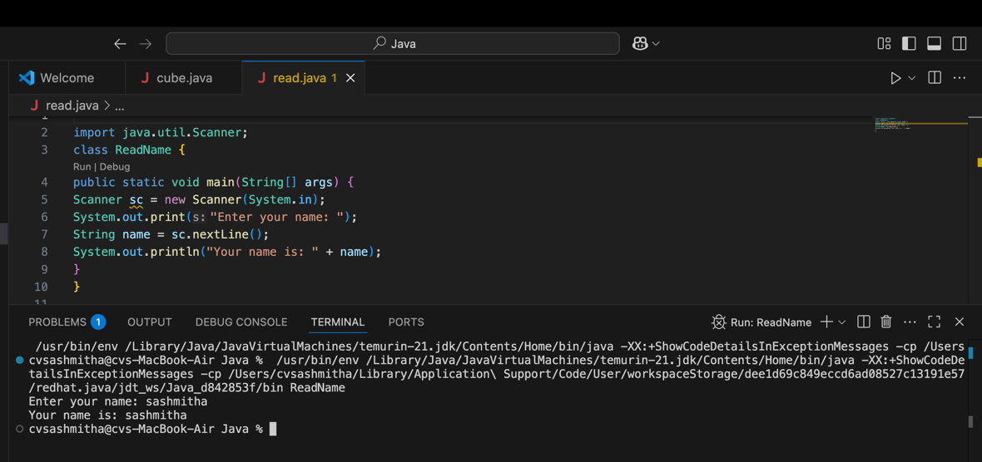
Output:
Enter your name: Anitha
Your name is: Anitha
Program 2: Read Two Numbers and Print Sum
Source Code:
import java.util.Scanner;
class SumInput {
public static void main(String[] args) {
Scanner sc = new Scanner(System.in);
System.out.print("Enter first number: ");
int a = sc.nextInt();
System.out.print("Enter second number: ");
int b = sc.nextInt();
int sum = a + b;
System.out.println("Sum = " + sum);
}
}
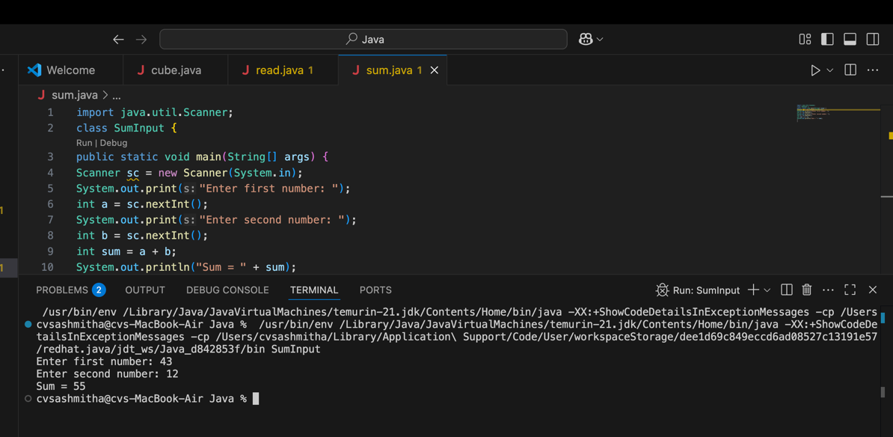
Output:
Enter first number: 5
Enter second number: 3
Sum = 8
Program 3: Read Length and Breadth and Find Area of Rectangle
Source Code:
import java.util.Scanner;

class AreaRectangleInput {
public static void main(String[] args) {
Scanner sc = new Scanner(System.in);
System.out.print("Enter length: ");
int length = sc.nextInt();
System.out.print("Enter breadth: ");
int breadth = sc.nextInt();
int area = length * breadth;
System.out.println("Area of Rectangle = " + area);
}
}
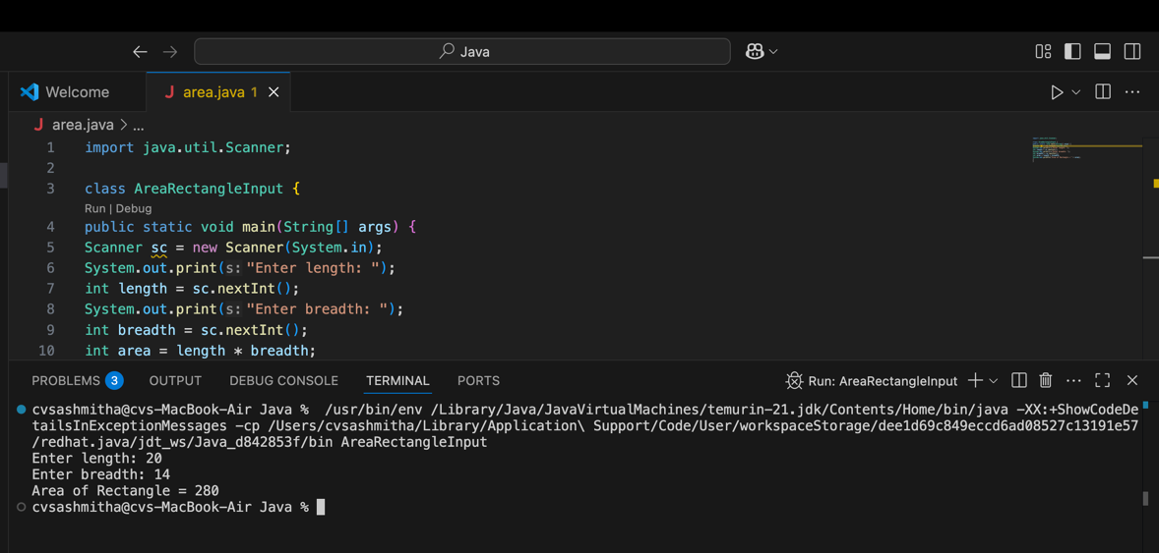
Output:
Enter length: 10
Enter breadth: 5
Area of Rectangle = 50

POST LAB EXERCISE
- What is the use of the Scanner class in Java?
The ‎`Scanner` class is used to read input from various sources, most commonly from the keyboard (‎`System.in`). It can read different types of data like ‎`int`, ‎`double`, ‎`String`, etc.

- Which package contains the Scanner class?
`Scanner` is in the ‎`java.util` package.
So you write:
‎`import java.util.Scanner;`

- What does System.in represent?
`System.in` is the standard input stream. It usually represents input from the keyboard. When you write ‎`new Scanner(System.in)`, you are telling Java to read from the keyboard.

- What does System.out represent?
`System.out` is the standard output stream. It represents the console/screen where your program prints output. For example, ‎`System.out.println("Hello");` prints text on the screen.

- Name any two methods used to read input using Scanner.
Common methods are:
  - ‎`nextInt()` – reads an integer
  - ‎`nextDouble()` – reads a decimal number
  - ‎`next()` – reads a single word (string without spaces)
  - ‎`nextLine()` – reads an entire line of text
Any two valid answers: for example, ‎`nextInt()` and ‎`nextLine()`.

- What is the difference between next() and nextLine()?
  - ▫ ‎`next()` reads only one word, stopping at the first space.
Example: input ‎`Hello World` → ‎`next()` gives ‎`"Hello"`.
  - ‎`nextLine()` reads the whole line, including spaces, until the user presses Enter.
Example: input ‎`Hello World` → ‎`nextLine()` gives ‎`"Hello World"`.So, ‎`next()` is for single tokens/words; ‎`nextLine()` is for full sentences/lines.

Result:

Thus the input was successfully read from the user and the corresponding output was displayed using Java input and output statements.

ASSESSMENT

Description | Max Marks | Marks Awarded
Pre Lab Exercise | 5
In Lab Exercise | 10
Post Lab Exercise | 5
Viva | 10
Total | 30
Faculty Signature

